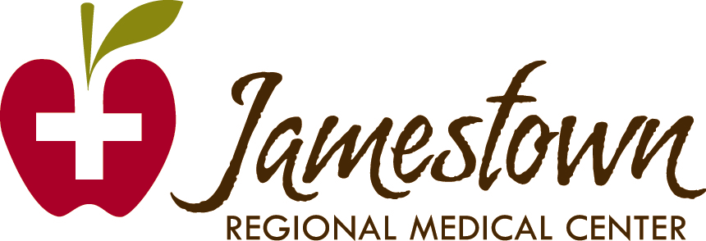

Total Shoulder Replacement

Instructions & Exercises to Enhance Your Recovery

Jamestown Regional Medical Center Physical Therapy & Occupational Therapy
2422 20th St SW, Jamestown, ND 58401
(701)952-4800, (800)281-8888 #3
What is Total Shoulder Replacement?

Total shoulder replacement (TSA) is a surgical procedure referred to as a shoulder arthroplasty. Worn, diseased, or damaged surfaces of a shoulder joint are removed and replaced with artificial components. In this procedure, the joint surfaces of the humerus and the scapula are involved. The artificial joint or “prosthesis” generally has two components; one made of metal, which is usually cobalt-chrome or titanium. The other component is a plastic material called polyethylene. The new joint works much like a natural shoulder. However, until it heals, your new shoulder will have limited movement and function. You may also have some discomfort. However, having a new shoulder means you’ll no longer experience arthritic pain in that joint, and in time, you can return to activities that you enjoy.

Prepare ahead for recovery

The recovery process can be aided by planning ahead by practicing exercises and making modifications in your home.
Tips/Recommendations:
- Store commonly used items within reach, between waist and shoulder level
- Use a hand held shower head for easier bathing.
- If bedroom is upstairs, consider sleeping in a “main floor” bed temporarily.

Post-Operative Concerns

- Bruising/discomfort/swelling: this will likely increase when you get home. Continue ice and elevation.
- Some difficulty sleeping
- Constipation associated with pain meds. Communicate needs to physician, consider stool softeners, prune juice, etc.
- The “blahs”: poor stamina with rapid fatigue, decreased appetite. Monitor health.
- An immobilizer will be placed on your arm to hold the shoulder in correct alignment. You will be instructed on how to put this on and when it can be removed.
- Use ice/cold packs 15-20 min 3-5x/day. If you received a cryo cuff ice cooler, use as instructed on cooler instructions, or by therapist in hospital.

Preparation for your hospital stay

- Take rubber soled shoes that are easy to take on and off. It is better to have a good fitting slip-on rather than lace up/tie shoes.
- Take clothes that are easy to put on such as elastic waist pants and large shirts that button instead of pull over the head.
- Take the name and number of your family doctor and pharmacy.
- You will receive Physical & Occupational Therapy during your hospital stay. Usually you will need Physical Therapy after you are discharged from the hospital.
- You will be discharged from therapy once you have achieved your goals
- If you are unable to return home safely (ie. Limited walking ability, unable to do stairs, unable to get in and out of bed) consider a Rehab of stay either 1-2 weeks at JRMC Swingbed, or 1-2 months at local Skilled nursing facility for Rehab. Home Health is also an option if you have nursing needs, and need ongoing rehab and are home bound.

Your Exercise Program

The better prepared you are, the easier your rehabilitation will be.

The following exercise program is designed to build strength and ease your recovery. Unless instructed otherwise by your Physical Therapist, try to perform each exercise 5-10 repetitions each once daily. Then increase to a total of 30 repetitions or 3 sets of 10, 1-2 times daily.

Call your Physical Therapist if:
- Any exercise causes increased pain or swelling in your shoulder or any other joint or area of your body.
- You are not sure how to safely perform the exercises.
- If you have any further related questions or concerns regarding your program.

Discontinue any exercise if it causes sharp or increased pain, dizziness, chest pain, shortness of breath, or any unusual symptoms and contact your physician.

This program is designed to assist you in regaining your mobility and strength following surgery.

Jamestown Regional Medical Center offers an extensive outpatient rehab program. Please call with questions.

Jamestown Regional Medical Center
Physical Therapy & Occupational Therapy
2422 20th St SW, Jamestown, ND 58401
(701)952-4800 or (800)281-8888 #3
www.jrmcnd.com

